**PRACTICAL: -4**

**AIM: -**To configure and use Cloud storage services like Amazon S3.

* Amazon S3 provides following services along with its specification.

1. **Object Storage:**

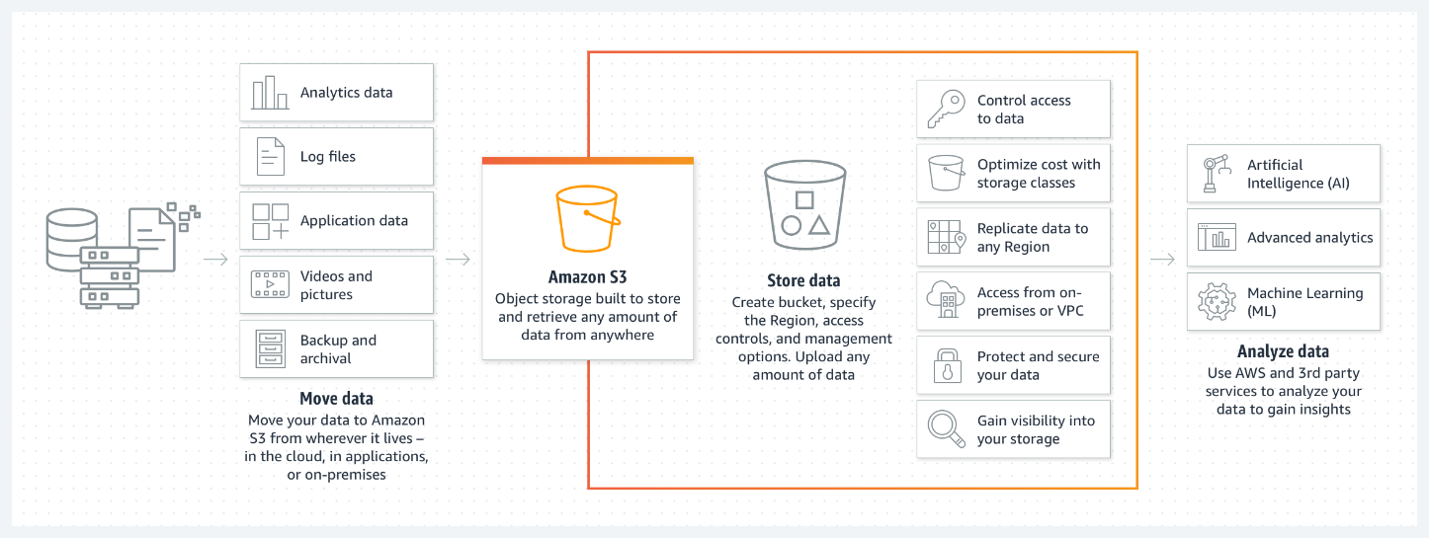

* + Stores data as objects within buckets.
  + Unlimited storage with different access tiers.

1. **Security and Access Control:**

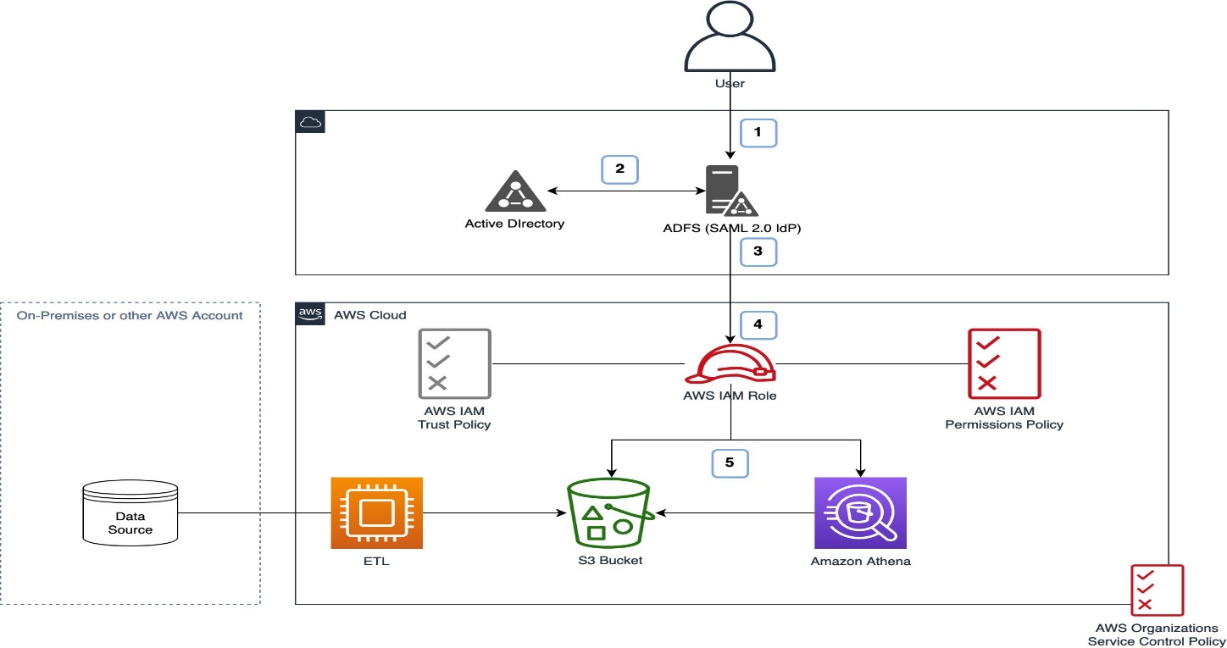

* + Provides Identity and Access Management (IAM) policies.
  + Supports encryption and bucket policies.

1. **Data Management and Backup:**

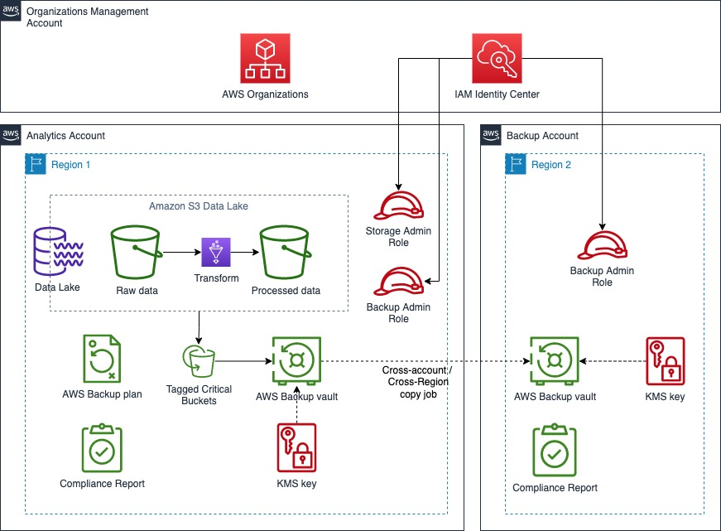

* + Versioning to track changes in files.
  + Lifecycle policies for automated data archiving.

1. **Scalability and Performance:**

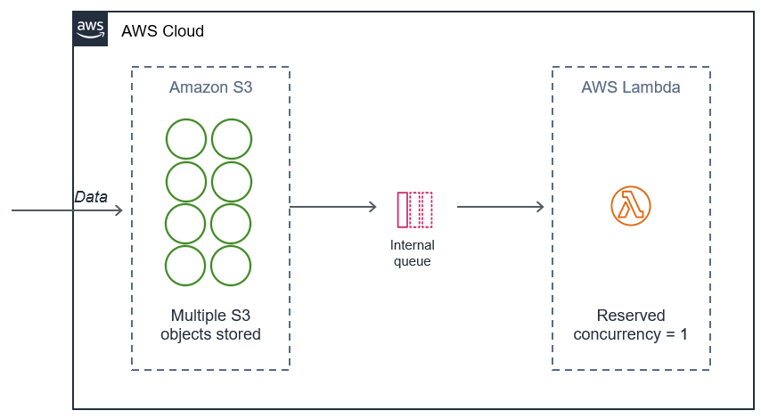

* + High availability and durability.
  + Supports integration with other AWS services.

1. **Cost Optimization:**

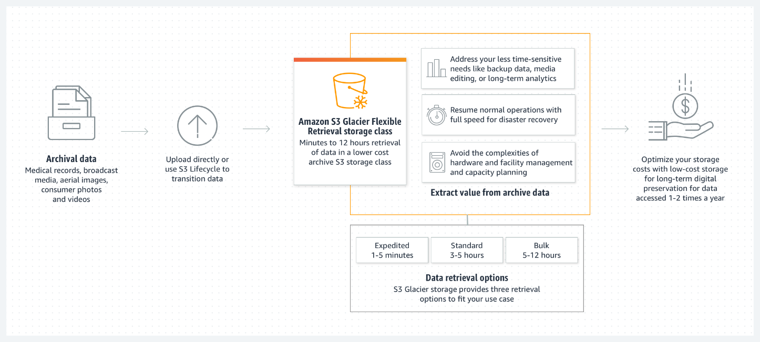

* + Different pricing tiers for standard, infrequent access, and archive storage.
  + Pay-as-you-go model.

**PRACTICAL: -5**

**AIM: -** To explore various Cloud Platforms like Google Cloud and describe its specification.

* Major Google Cloud Services and Specification.

1. **Compute - Google Compute Engine:**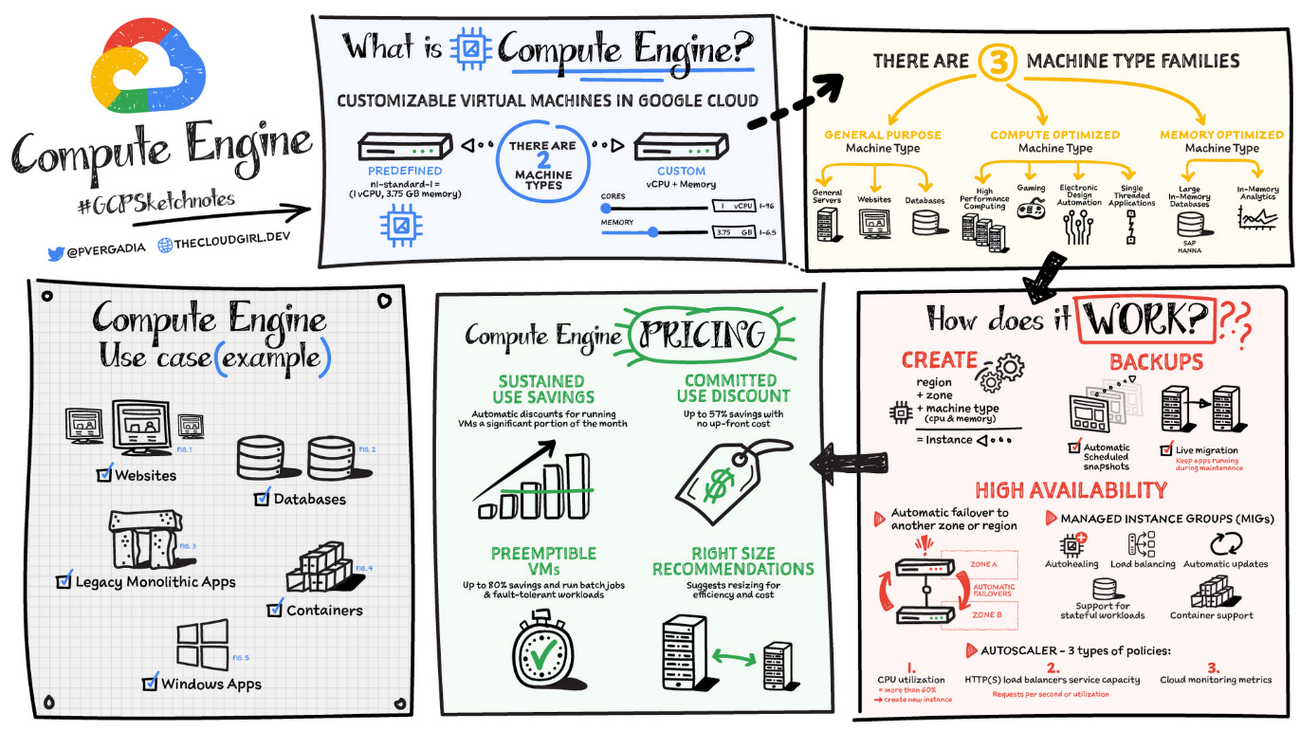
   * Provides virtual machines (VMs) for scalable computing.
   * Supports custom machine types and auto-scaling.
2. **Storage - Google Cloud Storage:**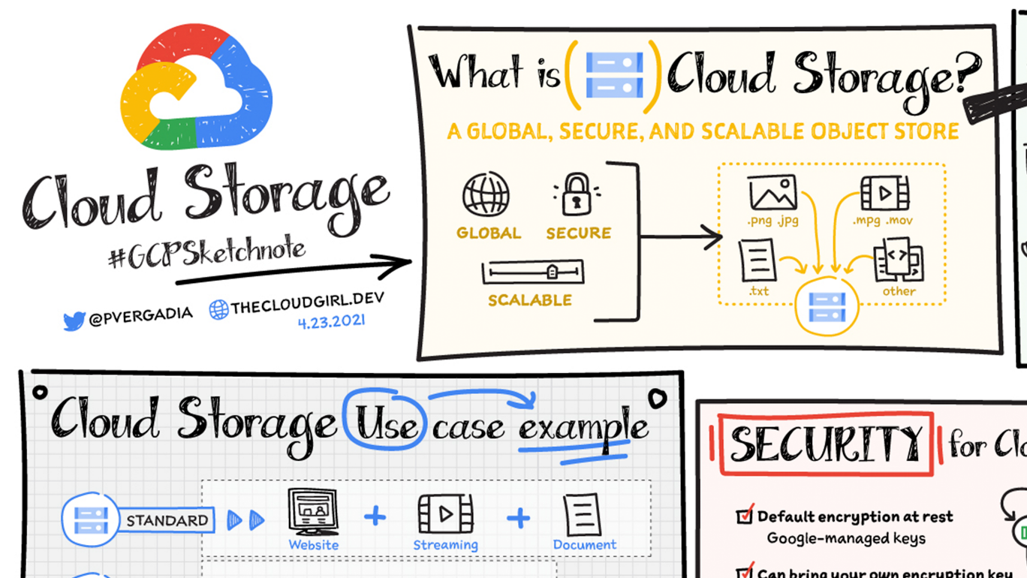
   * Offers object storage with different pricing tiers.
   * Supports lifecycle management and data encryption.
3. **Databases - Cloud Spanner / Firestore:**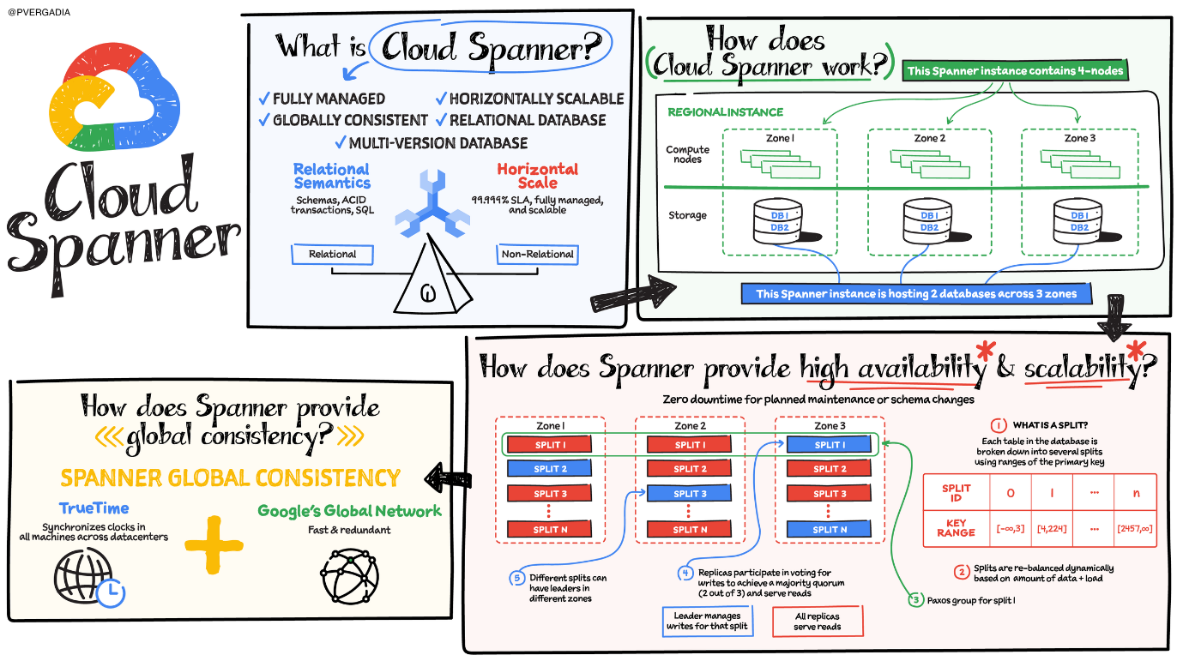
   * Cloud Spanner provides relational database services with horizontal scaling.
   * Firestore is a NoSQL document database.
4. **Networking - Virtual Private Cloud (VPC):**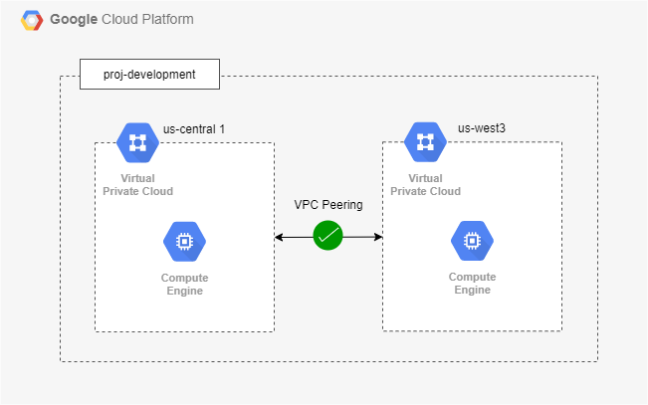
   * Allows network segmentation and security control.
   * Provides hybrid and multi-cloud networking.
5. **Security & Identity - Identity and Access Management (IAM):**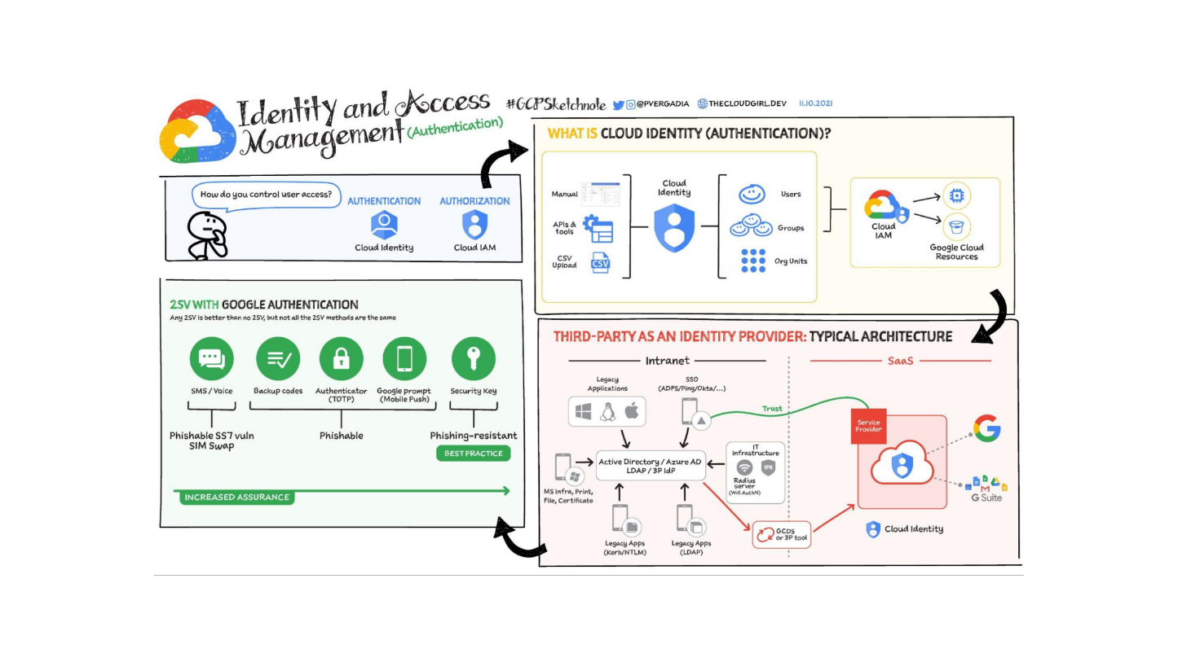
   * Manages permissions and authentication.
   * Supports role-based access control (RBAC).
6. **Machine Learning - AI Platform / Vertex AI:**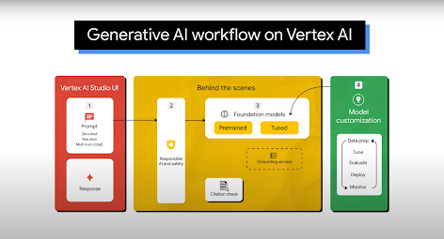
   * Supports training and deploying ML models.
   * Provides pre-trained models for NLP and vision.
7. **Big Data & Analytics - BigQuery:**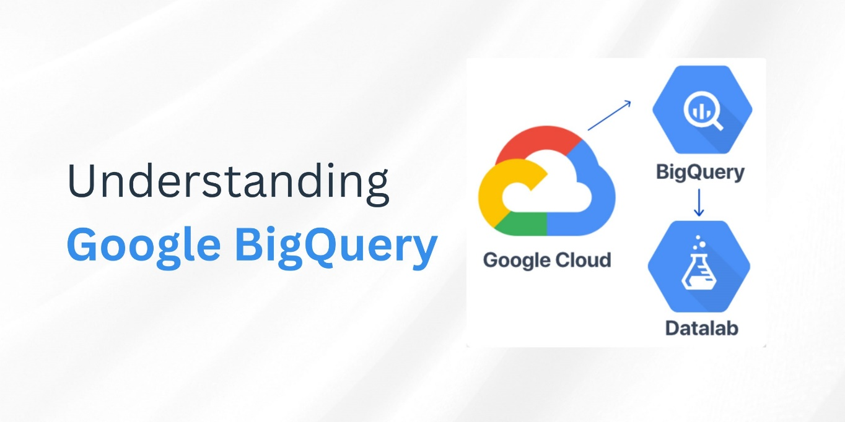
   * Fully managed data warehouse.
   * Enables high-speed SQL queries on large datasets.
8. **Developer Tools - Cloud Build:**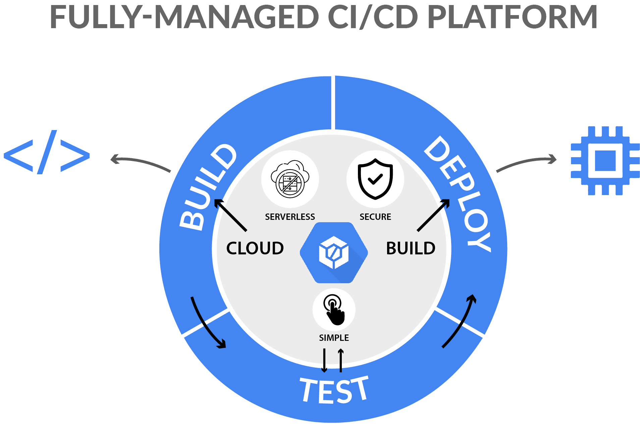
   * Supports CI/CD pipeline for automated builds.
   * Integrates with Kubernetes and Google Cloud Run.
9. **Business Applications - Google Workspace Integration:**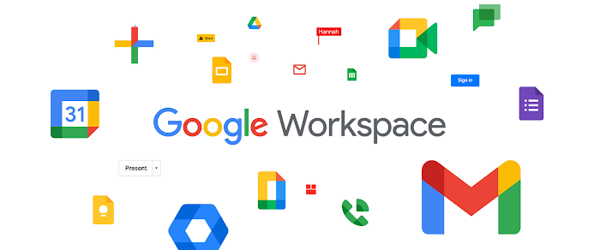
   * Includes Gmail, Google Drive, and Docs integration.
   * Supports cloud-based productivity tools.